BHS Terms and Conditions

Working Equitation Clinic with Cassy Gadsby
Poldice Valley – Sept, Oct, Nov & Dec 2025, Jan & Feb 2026

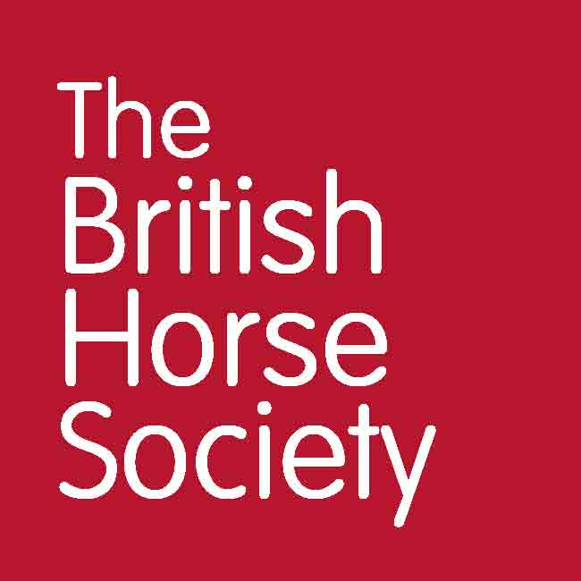

General
- Online entries only, no cash will be taken on the day.
- Tickets are non-transferable.
- Please report to the coach on arrival.
- Always follow the instructions of any marshals and officials.
- Everyone attending the event is responsible for ensuring the safety of themselves and others.
- The BHS, or the training venue, cannot provide supervision for attendees under the age of 18. It is a recommendation that any attendee below the age of 16 years should be accompanied by a responsible adult who remains at the venue for the duration of the course or event. For attendees aged 16-17, or an adult at risk, it is at the discretion of their parent or guardian. Accompanying adults may need to pay to attend the event, this is at the discretion of the event organiser.
- Please leave the parking area as you found it – don’t muck out your trailer or lorry in the parking area and take dung home with you.
- Dogs are NOT permitted.
- We may use photos, video, and information about you on BHS social media, website or magazines. You have the right to withdraw your consent at any time by emailing dataprotection@bhs.org.uk.
- For more details about how your personal data is used please take a look at our Privacy page: www.bhs.org.uk/privacy or contact dataprotection@bhs.org.uk.

Riders
- Hats to the current standard must always be worn and correctly secured. Please check yours meets current standards which can be found at: https://www.bhs.org.uk/go-riding/riding-out-hacking/what-to-wear/hats-and-helmets/.
- Body protectors are strongly recommended and should comply with current standards – also found on the BHS website at http://www.bhs.org.uk/body-protectors.
- Hats and body protectors (if you choose to wear a body protector) will not be checked. It is your responsibility that these are to the current standards. Please refer to https://www.bhs.org.uk/advice-and-information/tack-and-equipment/what-to-wear.
- All handlers must wear suitable footwear. Wellington boots and trainers are not allowed.
- No one must sit on/ride a horse unless they are booked as the event participant and have appropriate insurance cover.
- The BHS strongly recommends wearing hi-viz when riding and carriage driving.
- Handlers under 16 years must be accompanied by a responsible adult for the duration of the event.
- Handlers are advised to carry a mobile phone and be aware of the emergency contact number for the event.
- Handlers should have an appropriate level of fitness to safely undertake the activity.

Horses
- All horses must be of an appropriate fitness level for the activity being undertaken – hooves and shoes must be in good condition.
- Tack must be suitable, in safe condition and fit correctly.
- Any stallions must be informed to the organizer at the time of booking. No person may bring a stallion without ensuring, at all times, that other riders, horses and members of the public are not at risk. Stallions should be identifiable by a bridle tag and/or yellow tail ribbon. Any stallions deemed to be unsafe by the coach may be directed to leave the site.
- All horses must be up to date with annual equine influenza vaccinations and must be 6 days clear from their most recent booster vaccination. Further vaccination guidance can be found using the BRC Flu Vac Checker. (Before 1 Jan 2024) (After 1 Jan 2024). Spot checks will/may be made at the event.
- Horses should not be left unattended when tied to horseboxes, in the parking area.
- It is a legal requirement to have your horses’ passport when travelling to events.

Cancellations and Refunds
- Strictly no refunds, except if the event is cancelled due to unforeseen circumstances.
- Strictly no refunds for anyone who has booked and does not attend.
- In the case of cancellation by the attendee £5 will be retained to cover admin and booking fees.
- A refund, less an admin and booking fees, will be given to anyone who cancels up to 10 days prior to the event.
- If the event is cancelled by the BHS, the entry fee will be fully refunded.

- All British Horse Society events are checked for viability around ten working days beforehand. Any that have insufficient numbers may be cancelled. In this case, delegates who have booked will receive a full refund or free transfer should another suitable event be pending.
www.bhs.org.uk
www.facebook.com/TheBritishHorseSociety
www.twitter.com/britishhorse (@BritishHorse)
Disclaimer
The organisers have taken reasonable precautions to ensure the health and safety of everyone present. For these measures to be effective, everyone must take reasonable precautions to avoid and prevent accidents.

The British Horse Society is a Registered Charity Nos. 210504 and SC038516

