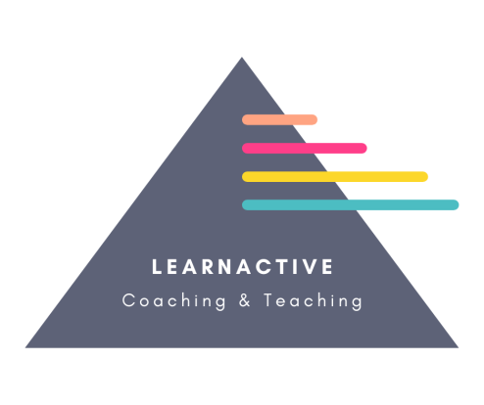
Modern Slavery Statement
LearnActive NW Ltd Modern Slavery Act Statement
Introduction

LearnActive NW Ltd is committed to preventing any form of modern slavery, human trafficking, or exploitation in our business operations and supply chains. This statement outlines the steps we have taken and will continue to take to ensure that modern slavery does not occur within our organisation or supply chain, in line with our responsibilities under Section 54 of the Modern Slavery Act 2015.
Who are we?
LearnActive NW Ltd provides wellbeing support for everbody and works with a variety of stakeholders, including partners, suppliers, and contractors. We are dedicated to ensuring that our business and supply chain operate ethically and responsibly, adhering to all applicable laws and regulations.
INTENT
Our Commitment to the Modern Slavery Act:
LearnActive NW Ltd recognises the importance of taking proactive steps to prevent modern slavery and human trafficking. We are committed to:
Ensuring our staff, contractors, and suppliers are aware of and comply with the Modern Slavery Act 2015.
Maintaining effective systems and controls to identify, prevent, and mitigate risks of slavery and human trafficking within our business and supply chain.
Upholding human rights standards and promoting fair and safe working conditions across all areas of our business.
IMPLEMENTATION:
We have implemented the following measures to ensure compliance with Section 54 of the Modern Slavery Act:
Risk Assessment: We have conducted a thorough risk assessment of our operations and supply chains to identify any areas where the risk of modern slavery might be present.
Supplier Due Diligence: We ensure that our suppliers and contractors comply with the Modern Slavery Act by incorporating anti-slavery requirements into our contracts. Suppliers are also required to provide information about their own anti-slavery policies and practices.
Training and Awareness: All LearnActive NW Ltd employees are made aware of the risks of modern slavery through training programs, enabling them to identify potential issues in our operations or supply chains and take appropriate action.
Reporting and Accountability: We encourage a culture of openness and accountability within our business, providing clear processes for reporting any concerns regarding modern slavery or unethical practices. Any issues reported will be investigated, and appropriate action will be taken.
Monitoring: we commit to:
Continuously review and improve our policies, procedures, and training programs to combat modern slavery.
Work closely with suppliers to ensure that they adopt best practices to prevent modern slavery within their own supply chains.

This statement is made in accordance with Section 54(1) of the Modern Slavery Act 2015 and constitutes LearnActive NW Ltd's modern slavery and human trafficking statement for the financial year ending April 2026

This statement has been approved by the Board of Directors of LearnActive NW Ltd.

Signed: 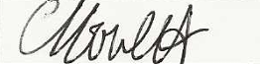
Connor Howlett
Director
2024 Statement

By publishing this statement, LearnActive NW Ltd acknowledges its responsibility to comply with Section 54 of the Modern Slavery Act and commits to upholding the highest standards in preventing modern slavery and human trafficking in its business and supply chains.

