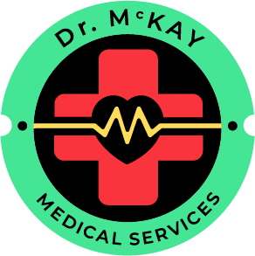
Booking & Cancellation Policy
We understand that plans can change. The following policy ensures fairness for both our clients and instructors while keeping courses running smoothly.

Bookings & Payments
- All course bookings require full payment in advance to confirm your place.
- Spaces are limited and allocated on a first-come, first-served basis.
- Once payment has been received, you’ll receive written confirmation and joining instructions.

Cancellations by the Client
If you need to cancel or reschedule, please let us know as soon as possible. Refunds are issued according to the notice period before the course start date:
- 21 days or more: Full refund.
- 14 – 20 days: 50 % refund.
- 7 – 13 days: 25 % refund.
- Less than 7 days: No refund (rescheduling may be possible if another course date is available).
At any point, you may transfer your booking to another participant at no additional charge. Please notify us of their name and contact details at least 24 hours before the course.

Cancellations by Dr McKay Medical Services
In the rare event that we must cancel or postpone a course (for example, due to illness, venue issues, or unforeseen circumstances), you will be offered:
- a full refund, or
- a transfer to a new course date of your choice.
We make every effort to avoid disruption and will notify you as soon as possible should changes occur.

