Haystax Limited and Haystax Holiday Lodges Risk Assessment

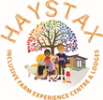
and Noo Noo’s Experiences Community Interest Company
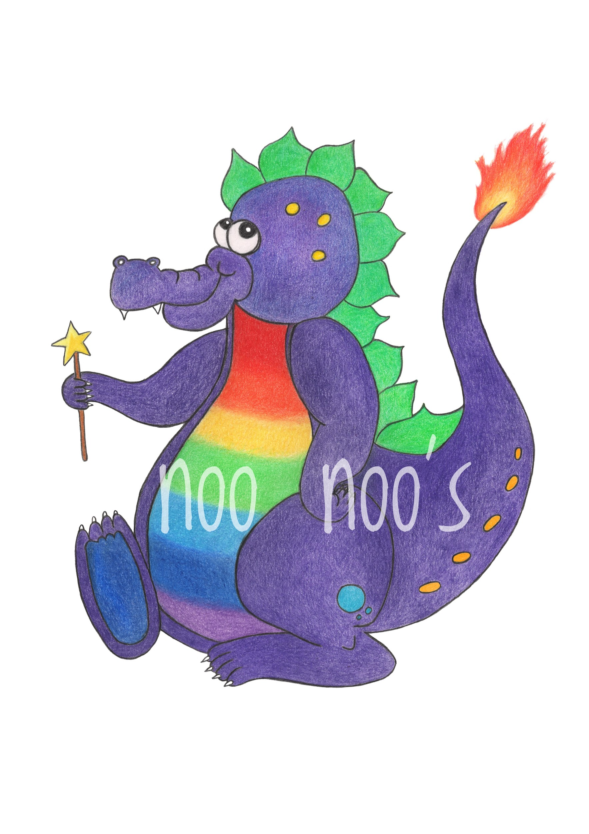
Name: | Access to Haystax Site During Site Development Risk Assessment for Groups of Adults (without children or vulnerable adults)
Assessment carried out by: | Dawn Adamson
Date: | 18.8.2024
Review Date: | Reviewed regularly in order to be responsive to the changing conditions on site.

This risk assessment works alongside the risk assessment written to cover the activity you will be completing on site. Please ensure you have read and understood both risk assessments before your visit.

What are the hazards? | Who is at risk and how? | Level of risk  (low, medium, high) vs benefits | What are the control measures? | Monitoring | Who is responsible? | How often should this happen?
Uneven ground with hard core surface. | Those at risk:  - Staff  - Visitors  - Volunteers  Risks:  - Falling on rough ground.  - Cutting or grazing the skin on the hard core.  - Twisting a knee or ankle.  - Breaking a bone in a fall. | Level of risk before controls:  - High  Level of risk after controls:  - Medium  Benefits:  - Access to the site.  - Building a self of achievement from being involved in the development of the site.  - Positive impact on wellbeing.  - Visitors will learn to manage their own risks while being in environments that pose some risk. | - Surface has been levelled out  - Staff will check the area volunteers and visitors are going to be working in before their arrival for any hazards.  - Visitors and volunteers are advised to wear sensible and sturdy footwear.  - Visitors and volunteers will be asked to stay within the bounds of the area in which they are working in.  - Our site is not yet accessible to those in wheelchairs or with limited mobility. We do not recommend that they visit the site at this time.  - A first aid kit will be available on site. | Remind visitors and volunteers to wear suitable footwear. | Management | Before the visit and at the start of a session.
 |  |  |  | Remind visitors and volunteers to walk carefully around the site watching their footing. | Management | Before the visit and at the start of a session.
Trenches | Those at risk:  - Staff  - Visitors  - Volunteers  Risks:  - Falling into a trench and injuring oneself.  - Tripping or slipping on displaced soil from the trenches.  - Sprains, broken bones, cuts, grazes and broken skin. | Level of risk before controls:  - High  Level of risk after controls:  - Medium  Benefits:  - Access to the site.  - Building a self of achievement from being involved in the development of the site.  - Positive impact on wellbeing.  Visitors will learn to manage their own risks while being in environments that pose some risk. | - Trenches are clearly visible and are never hidden from sight.  - Trenches are away from the areas in which visitors and volunteers will be working.  - Visitors and volunteer groups will be informed of the trenches when organising their visit and at upon arrival on the site.  - Visitors and volunteers will be asked to stay within the bounds of the area in which they are working in.  - A first aid kit will be available on site. | Remind visitors and volunteers to stay within the area they are working in. | Management | Before the visit and at the start of a session.
Heavy machinery | Those at risk:  - Staff  - Visitors  - Volunteers  Risks:  - Being run over.  - Crush injuries.  - Injuring from equipment falling from machinery .  - Falling from equipment  - Being injured whilst equipment is in operation. | Level of risk before controls:  - High  Level of risk after controls:  - Medium  Benefits:  - Access to the site.  - Building a self of achievement from being involved in the development of the site.  - Positive impact on wellbeing.  - Visitors will learn to manage their own risks while being in environments that pose some risk. | - Heavy machinery will not be operated in any areas in which visitors and volunteers will be working.  - Should a vehicle or piece of machinery need to move around the site during a group’s visit and will come close to the group, a member of staff will ensure the group are moved to a safe distance.  - Visitors and volunteers will be asked to stay within the bounds of the area in which they are working in.  - A first aid kit will be available on site. | Remind visitors and volunteers to stay within the area they are working in. | Management | Before the visit and at the start of a session.
 |  |  |  | Remind contractors on site that they must stay away from the areas in which groups are working. | Management | On the day of each visit.
Unattended building materials | Those at risk:  - Staff  - Visitors  - Volunteers  Risks:  - Tripping and falling from piles of materials.  - Falling onto piles of equipment.  - Being injured by falling or rolling materials. | Level of risk before controls:  - High  Level of risk after controls:  - Medium  Benefits:  - Access to the site.  - Building a self of achievement from being involved in the development of the site.  - Positive impact on wellbeing.  - Visitors will learn to manage their own risks while being in environments that pose some risk. | - Building materials will not be left in areas where visitors and volunteers are working.  - All building materials will be secured to ensure that they cannot roll or fall over.  - If this is unavoidable, they will be cordoned off and groups will be closely supervised around them.  - Visitors and volunteers will be asked to stay within the bounds of the area in which they are working in.  - A first aid kit will be available on site. | Materials will be checked before each visit. | Management | Before each visit.
 |  |  |  | Remind visitors and volunteers to stay within the area they are working in. | Management | Before the visit and at the start of a session.
Weather conditions | Those at risk:  - Staff  - Visitors  - Volunteers  Risks:  - Sunburn  - dehydration  - hypothermia | Level of risk before controls:  - Medium  Level of risk after controls:  - Low  Benefits:  - Access to the site.  - Building a self of achievement from being involved in the development of the site.  - Positive impact on wellbeing.  - Visitors will learn to manage their own risks while being in environments that pose some risk. | - Visitors and volunteers will be asked to dress appropriately for the weather/ ground conditions.  - We recommend visitors and volunteers wear insect repellent during the summer months.  - Visitors and volunteers will be informed of the limited shade and shelter in the field in which they will be working.  - Visitors will have access to shaded areas during breaks on hot days. This will not be possible on windy days due to risks posed by the trees that provide shade.  - Visitors and volunteers will be asked to bring drinks to site as drinking water is not yet available. There will be a few bottles of water available for emergencies.  - A first aid kit will be available on site. | Be aware of weather forecast for time on site. | Management | Day of visit.
Trees in high winds | Those at risk:  - Staff  - Visitors  - Volunteers  Risks:  - Falling branches during or after high winds | Level of risk before controls:  - High  Level of risk after controls:  - Medium  Benefits:  - Access to the site.  - Building a self of achievement from being involved in the development of the site.  - Positive impact on wellbeing.  - Visitors will learn to manage their own risks while being in environments that pose some risk. | - Staff will monitor weather forecasts and if the wind speed means the area in which visitors and volunteers will be working in will be unsafe, they will be given as much notice as possible and asked not to attend the site.  - If visitors and volunteers are working away from the trees and it is deemed safe for them to attend during high winds, they will be advised to stay away from the tree line.  - Management will inspect trees on a regular basis, especially after high winds to ensure they are safe before visitors and volunteers arrive.  - Visitors and volunteers will be asked to stay within the bounds of the area in which they are working in.  - A first aid kit will be available on site. | Inspect trees in the areas in which groups will be working in. | Management | Before each visit.
 |  |  |  | Monitor wind speed during visits. If wind speeds reach an unsafe level, (level TBD) ensure the group are moved to a safe area of the site. | Management | Throughout visit to site.
 |  |  |  | Remind visitors and volunteers to stay within the area they are working in. | Management | Before the visit and at the start of a session.
Soil contamination. Including animal faeces, pesticides, water, and other contaminants. | Those at risk:  - Staff  - Visitors  - Volunteers  Risks:  - Illness  - Infection  - Ingestion  - Tetanus  - Leptospirosis (Weil’s disease)  - Toxocariasis (roundworm)  - Other infections. | Level of risk before controls:  - High  Level of risk after controls:  - Medium  Benefits:  - Access to the site.  - Building a self of achievement from being involved in the development of the site.  - Positive impact on wellbeing.  - Visitors will learn to manage their own risks while being in environments that pose some risk. | - Sheep have not been kept in the main field for a minimum of three weeks and faeces has been removed from the areas that will be accessed by members of the public at least three weeks prior to any visits.  - The owners of any dogs who visit the site are asked to pick up their faeces immediately and dispose of it appropriately. DO WE NEED TO PROVIDE A BIN FOR THIS PURPOSE?  - All lacerations, cuts, or open wounds (eczema, psoriasis, paper cuts) must be covered with a dressing prior to commencing work to minimise the risk of infection.  - Everyone must ensure they are wearing the correct PPE when handling soil, such as appropriate clothing and gloves.  - Volunteers will be informed not to touch their faces or mouths while handing soil.  - Visitors and volunteers will be asked to stay within the bounds of the area in which they are working in.  - A member of staff will be on site to supervise visitors and volunteers.  - Hand sanitiser will be available on site.  - A first aid kit will be available on site, but schools and organisations are asked to provide their own first aider. | Check the area in which groups are working for faeces including that from wild animals. | Management | Before each visit.
 |  |  |  | Remind visitors to wear appropriate PPE and to not touch their faces and mouth while handling soil | Management | Before the visit and at the start of a session.
 |  |  |  | Remind and encourage visitors to pick up after their dogs and bins to be provided. | Management | When a dog owner enters the site.
Insect stings and bites, including those from ticks, bees, wasps, and other insects. | Those at risk:  - Staff  - Visitors  - Volunteers  Risks:  - Bites and stings.  - Anaphylaxis.  - Insect and tick-borne diseases such as Lyme Disease. | Level of risk before controls:  - High  Level of risk after controls:  - Medium  Benefits:  - Access to the site.  - Building a self of achievement from being involved in the development of the site.  - Positive impact on wellbeing.  - Visitors will learn to manage their own risks while being in environments that pose some risk. | - We recommend visitors and volunteers wear insect repellent during the summer months.  - To minimise the risk of ticks, visitor and volunteers should cover their arms and legs with suitable clothing wherever possible.  - Visitors are advised to complete tick checks when they return home to ensure any ticks are not embedded in the skin.  - A first aid kit with tick removers will be available on site.
Slips, trips and falls | Those at risk:  - Staff  - Visitors  - Volunteers  Risks:  - Uneven surfaces  - Slippery, wet, or muddy floors and surfaces  - Trip over obstructions on floor | Level of risk before controls:  - Medium  Level of risk after controls:  - Low  Benefits:  - Access to nature and the animals year-round is good for wellbeing.  - Learning opportunities.  - Visitors will learn to manage their own risks while being in environments that pose some risk. | - Surfaces have been levelled out.  - Staff will check the area volunteers and visitors are going to be working in before their arrival for any hazards.  - Visitors and volunteers are advised to wear sensible and sturdy footwear.  - Visitors and volunteers will be asked to stay within the bounds of the area in which they are working in.  - A first aid kit will be available on site. | Sensible footwear advised. | Management | Before the visit and at the start of a session.
 |  |  |  | All visitors are advised to take care on site. | Management | Before the visit and at the start of a session.
Security of premises, entering and exiting - damage to fences, walls, barbed wire, entrance/ exit gates. | Those at risk:  - Staff  - Visitors  - Volunteers  Risks:  - Injuries from damaged walls, piles of loose material and barbed wire.  - Absconding from premises. | Level of risk before controls:  - High  Level of risk after controls:  - Medium  Benefits:  - Access to the site.  - Building a self of achievement from being involved in the development of the site.  - Positive impact on wellbeing.  - Visitors will learn to manage their own risks while being in environments that pose some risk. | - Visitors and volunteers will be asked to stay within the bounds of the area in which they are working in.  - A first aid kit will be available on site. | Remind visitors and volunteers to stay within the area they are working in. | Management | Before the visit and at the start of a session.
Contractors and staff on site who are not DBS checked. | Those at risk:  - Staff  - Visitors  - Volunteers  Risks:  - Contact between children and vulnerable adults and those who pose a potential risk to them. | Level of risk before controls:  - High  Level of risk after controls:  - Medium  Benefits:  - Access to the site.  - Building a self of achievement from being involved in the development of the site.  - Positive impact on wellbeing.  - Visitors will learn to manage their own risks while being in environments that pose some risk. | - Organisations will be informed of this when organising their visit and reminded about it upon arrival.  - Contractors will be asked to keep their distance from groups. | Remind visitors and volunteers to stay within the area they are working in. | Management | A first aid kit will be available on site.
 |  |  |  | Remind contractors on site that they must stay away from the areas in which groups are working. | Management | On the day of each visit.

