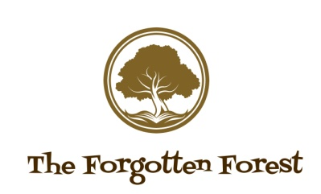
514 Bradford Road, Bailiff Bridge, Brighouse, HD6 4ED – 07708398548

CONSENT

- I agree to my child taking part in the workshop.
- I understand that there are risks but the benefit outweighs the risk and is also a learning opportunity.
- I understand that my child will, at an appropriate level, have opportunities to work with hand tools such as hammers.
- I understand that there are potential risks such as uneven surfaces, fires and a pond at the site.
- I will ensure that I will supervise my child at all times.
- I consent for my child to receive emergency first aid should the need arise, and for my child to receive emergency treatment from healthcare professionals.

WAIVER AND RELEASE FROM LIABILITY

By this Waiver, I assume any risk, and take full responsibility and waive any claims of personal injury, death or damage to personal property associated with Forgotten Forest Outdoor Play and Forest School Provision activities and events organized by Sarah Parker and her employees.
I understand and confirm that by signing this WAIVER AND RELEASE I have given up considerable future legal rights. I have signed this Agreement freely, voluntarily, under no duress. My signature is proof of my intention to execute a complete and unconditional WAIVER AND RELEASE of all liability to the full extent of the law. I am 18 year of age or older and mentally competent to enter into this waiver.
I have read, understand and agree to the waiver.

