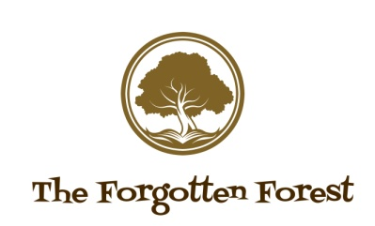
514 Bradford Road, Bailiff Bridge, Brighouse, HD6 4ED – 07708398548

PHOTO WAIVER
I grant to FORGOTTEN FOREST Outdoor Play Provision and Forest School the right to take photographs of me and my family in connection with the above-identified events.
I agree that Berkeley Forest School may use such photographs of me without my name and for any lawful purpose, including for example such purposes as publicity, illustration, advertising, and Web content .

