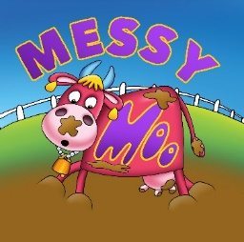

Please make sure that your child/children are wearing clothes that you are happy for them to get messy. Moo Music cannot guarantee that all of the mess will wash out.

This is to confirm that today’s event is parent led. There is a mixture of edible and non-edible mess to play with and this is to be monitored closely by the parent/carer named below. It is the responsibility of you the parent/carer to supervise your child at all times. Please only allow your child to play in and taste mess that you are happy for them to do so and that you, yourself deem suitable.

All of today’s stations are taste safe, this means that while they are made from edible ingredients they are not prepared with the intention of being consumed.

I, Caroline Muir, will explain each of the stations at the beginning of the session and be on hand to answer any questions regarding the mess and what is in it, throughout.

Moo Music will be taking photographs during the session.
These photographs may be posted on our social media pages and may be used in promotion of Moo Music and future events. Please indicate if you are happy with photos being used in this way (please circle) YES / NO.
If you tick No it is the parent/carer responsibility to ensure your child is wearing a red sticker throughout.
You are welcome to take photos of your own little one but please be careful not to inadvertently take photos of others.

There is a towel at each station to clean up spillages and baby wipes if needed. Please report anything you are not happy to wipe up yourself to Caroline (or session leader) asap. The nature of the activity means that the floor and stations can get slippy please take care when moving around the room for this reason. The tarpaulin is used to prevent damage to the hall floor, please be careful when stepping on and off the tarpaulin to prevent trips and further mess.

Please speak to Caroline (or session leader) before the session if you have any questions.

- Childs Name:
- Parent Signature:
- Parent Name:
- Date:

