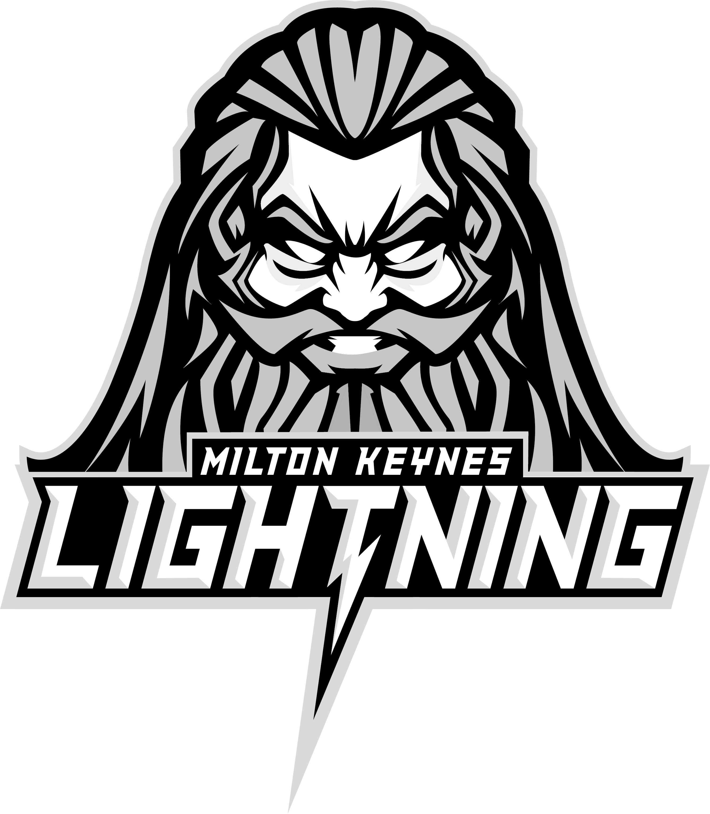

VIP and Group Ticketing Information

Thanks for booking to come and see Smith Recycling Milton Keynes Lighting play at Planet Ice in Milton Keynes.

If you want to learn more about one of the fastest team sports before you come along, have a look at www.mk-lightning.co.uk

Ticket delivery
- Tickets will be emailed (from Planet Ice) to the email address supplied when booking – when the match is released for general sale – usually 3 matches before.
- VIP tickets will be issued with a lanyard or wristband to allow entry to the VIP Skybar area. This will be issued on entry to Planet Ice.

Useful information
Please note you are not allowed to bring your own food into the rink, but there are a number of food and drink options available for purchase during the game. Bags may be searched on entry.

Kids food options: if you have ordered the food option, please advise us at least 48 hours in advance of any food allergies and we will let you know the details of how these can be accommodated. You have a set menu which is enclosed in the attachments section. Please arrive at the rink 90 mins before faceoff so your food can be served prior to warmup.

VIP food options: Please advise us at least 48 hours in advance of any food allergies and we will let you know the details of how these can be accommodated. You have a set menu which is enclosed in the attachments section of your booking.

Timings
Saturday matches  - Doors open for childrens’ groups with food: 5:30pm  - Doors open for everyone: 6:00pm  - Warm up: 6:20pm  - Team introductions and National Anthem: 6:55pm  - Faceoff: 7:00pm  - Approximate end time: 9:30pm | Sunday matches  - Doors open for everyone: 4:30pm  - Warm up: 4:35pm  - Team introductions and National Anthem: 5:10pm  - Faceoff: 5:15pm  - Approximate end time: 7:45pm

Arrive early to avoid entrance queues at security for your group.

Venue
The address of the rink is 1 S Row, Elder Gate, Milton Keynes MK9 1DL. It is located a 5 minute walk from the train station.

Parking – Planet Ice has limited parking at the rink. There is plenty of parking available outside of Morrisons (Pay and Display). If you park in the underground carpark at Morrisons, please be advised they lock it 1 hour after the store closes, and it is not opened again until the store next opens.

Lastly, the best way to see is happening before your match, check out our social media accounts below:

Facebook: https://www.facebook.com/MKLightningIHC/

Instagram: https://www.instagram.com/mklightningIHC/

Twitter: https://twitter.com/MKLightningIHC

See you at the rink,

#letsgolightning #powerofzeus #mkl

