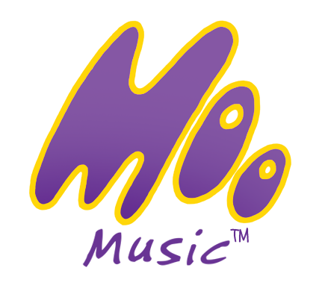

Coronavirus policy
The coronavirus policy for Moo Music HNLSWL (updated 28/07/2020)

As from 1st August 2020 we are allowed to hold Mother and baby sessions at the Mama Wellness studio….. Moo Music. This document does not replace medical or government guidelines. This document sets out guidelines for the safe return to sessions, within the law, and should be considered along with our existing risk assessment..

Anyone seeking advice on coronavirus should see https://www.gov.uk/coronavirus and we expect this advice to be followed, therefore anyone with relevant symptoms should not attend sessions. PPE is optional; however it is not encouraged because children need to be able to see your facial expressions and interact during the session.

We will be running sessions, with a group size of 10 places this includes one adult and one child so twenty attendees in total, please only come one family member per child. Customers are encouraged to walk or drive to the venue and avoid public transport if possible. Due to the extra spacing required to social distance the venue will not allow for pram space, there is parking at the Mary Forryan Ctr opposite the New Plough Inn which requires a £1 payment to be made in the car park box on entry to the sessions In some case 1 or two prams can be stored safely down stairs, but it is important not to block any fire exits.

To run sessions safely, session plans and session leaders will adhere to the following-:

- Moo Music - Provide individual prop bags with clean props inside/or separate props placed at your station.
- Moo Music - Plan games that do not require sharing of props.
- Moo Music - Plan games that do not require contact between children.
- All sessions - Set up at least 2 metres from customers and remain at least 2 metres from customers.
- All sessions - Wash hands immediately before and after sessions.
- Moo Music - Wear PPE face visor for singing sessions and to assist with first aid
- Moo Music - Remove props immediately after sessions, to be cleaned.
- All sessions – Clean mats in viricidal solution between sessions.
- All sessions – Clean floor in the venue with viricidal solution between sessions.

Customers will be expected to:-

- Stay away if you or your child have displayed symptoms of Covid19 in the last 7 days. https://www.gov.uk/government/publications/covid-19-stay-at-home-guidance/stay-at-home-guidance-for-households-with-possible-coronavirus-covid-19-infection
- Use hand sanitiser before and after each session and on washing hands and leaving the bathroom. This will be provided at three different stations within the venue.
- Adhere to the social distancing regulations and stay on your mat and away from anyone else.
- Discourage children from getting too close to others. In line with guidelines for early years education we acknowledge that this will be difficult and parents must accept it may happen, however please try and keep your child on your designated mat.
- Bring individual drinks if needed and do not share them. Do not eat during sessions.
- Bring tissues and do not share them with others and take dirty tissues home with you.
- When using the toilet and nappy facilities, please wipe with anti bac wipes before and after. However please note that the facilities will be deep cleaned between sessions also. Please take all nappies home with you.
- Please advise Cheryl via phone or email if your child develops symptoms within 48 hrs of a session and went within 2 metres of anyone else.

Please do contact me with any queries around this policy, or for general guidance please follow the link at the top. On both a personal and professional level, Moo Music is important for myself and my customers. We are all learning to deal with this unprecedented situation and I strive to get things right for us all.

Love and Maggie Moo kisses
Cheryl

T&C 1 (New customers).…Please read the Coronavirus Policy Document and be prepared to follow the guidelines. You must not attend if you or your child has had coronavirus symptoms in the last 7 days. Children remain the responsibility of their carers at all times. Moo Music is not responsible for your personal possessions. Due to numbers being so limited, unfortunately missed sessions cannot be carried over or refunded. Strictly only 1 adult is allowed per family. By making payment and joining sessions I assume you've agreed these terms and the terms of our Coronavirus Policy Document.

