Welcome to Giant Foam Bricks Playland
At The Beacon Museum

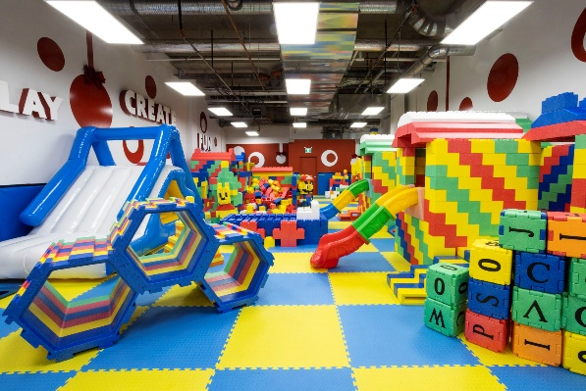

Before you and your children dive into the fun, we kindly ask you to carefully read and understand the following disclaimer. By entering and using Giant Foam Bricks Playland, you acknowledge and agree to the terms outlined below:

Use at Your Own Risk: The soft play area is designed for entertainment and physical activity. While we take every precaution to ensure a safe environment, the use of this facility is at your own risk. We are not liable for any injuries, accidents, or harm that may occur during your visit. Please be aware of surroundings, particularly the walls.

Supervision is Essential: Parents and guardians are required to actively supervise their children at all times. The soft play area can be a dynamic and energetic space; therefore, it is crucial that responsible adults keep a close eye on their children's activities to prevent accidents and ensure their well-being.

Age and Capacity Limit: For the safety and enjoyment of all visitors, the soft play area is designed to accommodate a maximum of 15 users. No more than three children should be accompanied by one adult supervisor.
The Playland is designed for children aged 0 to 8yrs. Please adhere these age and capacity guidelines.

Appropriate Attire: All participants are advised to wear appropriate clothing and to remove shoes while using the soft play area. Sharp objects, jewellery, and items that may pose a risk to the safety of individuals or the equipment should be removed before entering the area.

Hygiene and Health: We strive to maintain a clean and sanitary environment. We kindly ask that visitors and children refrain from using the play area if they are experiencing any illness, such as contagious infections or cold-like symptoms. Help us keep the area safe for everyone.
Strictly no food or drink is allowed in the play area.

First Aid and Emergencies:
In case of an emergency, please alert a staff member immediately. We have a dedicated First Aider onsite throughout the day.

By entering the soft play area, you acknowledge that you have read and understood this disclaimer and agree to abide by its terms. We aim to provide a safe and enjoyable experience for all visitors, and your cooperation is essential in achieving this goal. Thank you for choosing to spend time with us, and we hope you and your children have a wonderful and safe playtime experience.

Name of guardian (block letters) …………………………………………

Number and age of child/children.………………………………………

Signature of guardian…………………………………………………………

Date and time of entry……………………………………………………….



