
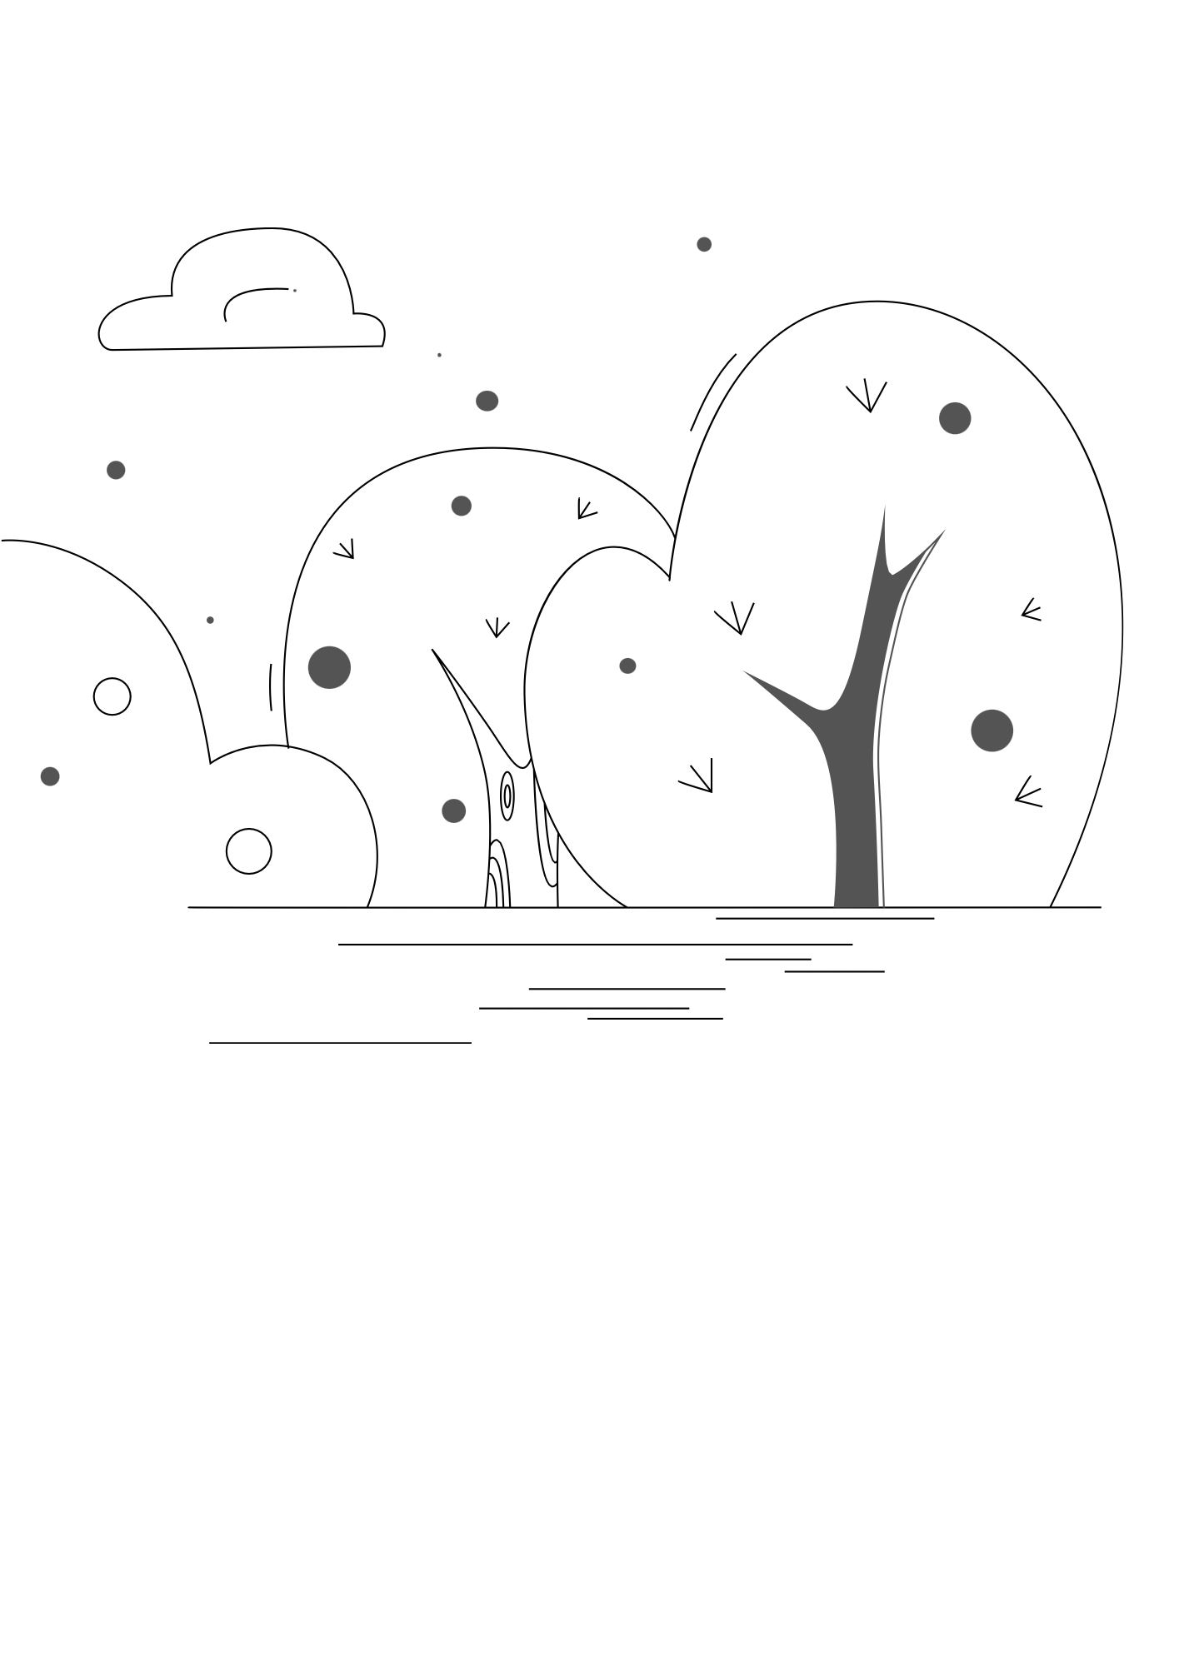

Forest School
Terms and Conditions

Client Responsibilities

- Suitable clothing and footwear must be worn to each session. We are an ‘all weather’ activity which means children will be exposed to various types of weather, whether it be rain, snow or sunshine.
- Our sessions are child-led and therefore we recommend that you follow your child’s cues and interests throughout the session to support their exploration. Poppy will be available to assist in any way.
- Please arrive no more than 5 minutes before your session to enable us to set up all equipment for each session.
- Allergies must be communicated prior to your visit so that we can accommodate in the best way possible.
- Our maximum capacity is 15 children per session. Therefore, we cannot accept additional children who have not been pre-booked.
- Please park respectfully around the area, keeping all driveways and bus stops clear.
- All guests must remain in the boundary area indicated by flags. This is to ensure the safety of all participants as well as the general public using the surrounding area.
- Parents/ guardians are responsible for their child/ children during the sessions and must be vigilant during activities.
- If the weather conditions are too dangerous for us to run a session, you will be informed as soon as possible. An alternative date will then be given for you to attend.
- When the fire pit is lit, each parent/ guardian must sit in the fire circle with their child.
- If you are unable to attend a session, 24hr notice must be given. We do not offer refunds but can offer an alternative date that best suits for you to attend.

