What is a Pass?

A Pass allows you to purchase a block of classes that you can redeem later for a set price. Passes are set up and are an option for **Event Organisers**, and they decide the price and number of uses.

Purchasing Passes

If offered by your **Event Organiser**, You can find passes near the top of the booking page:

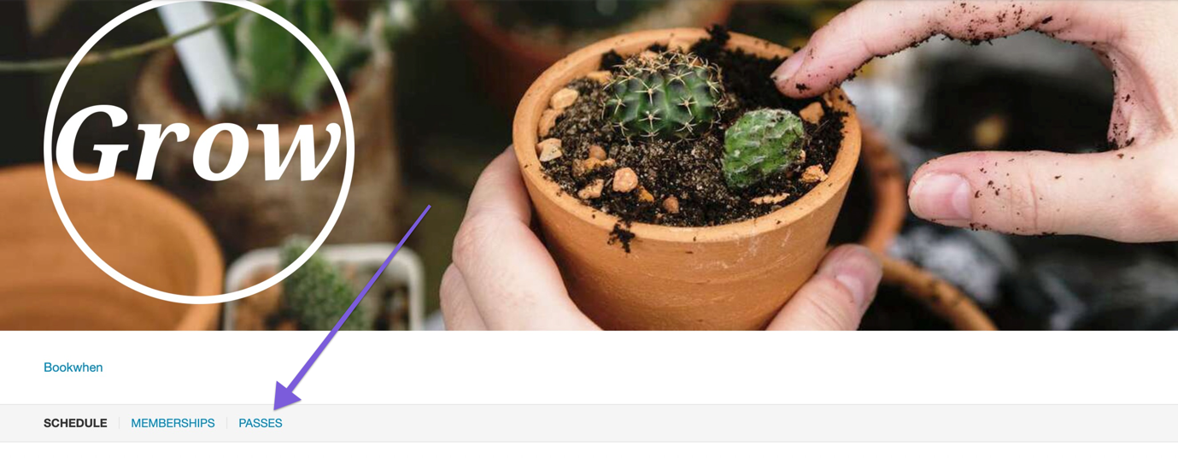

To add the Pass to your basket, select the blue **Select** button:

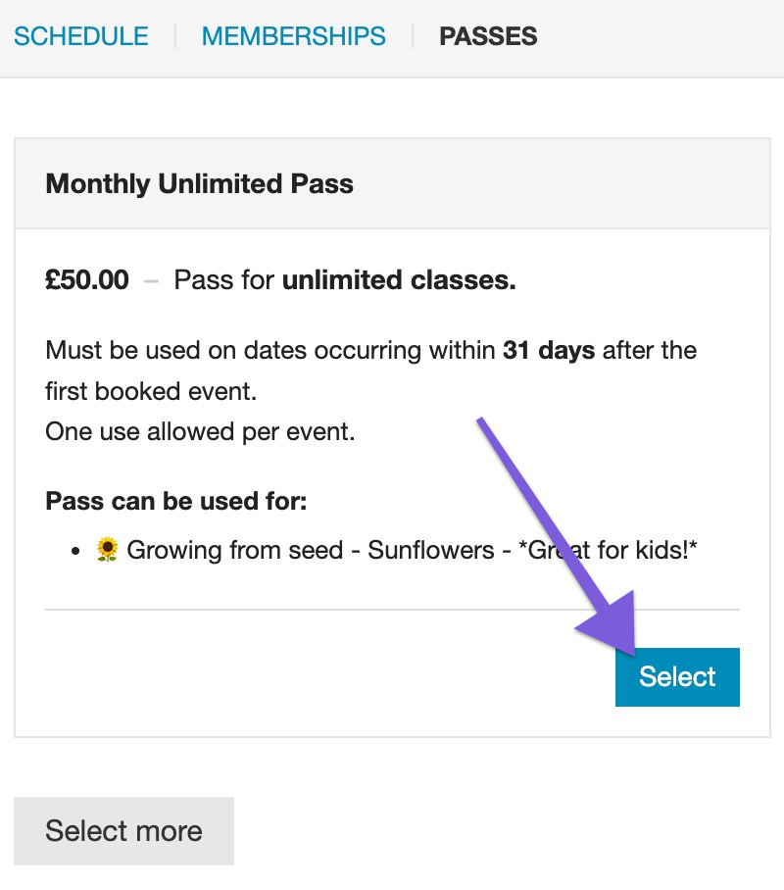

To purchase a Pass, **you must select at least one event** included in the Pass in the same transaction:

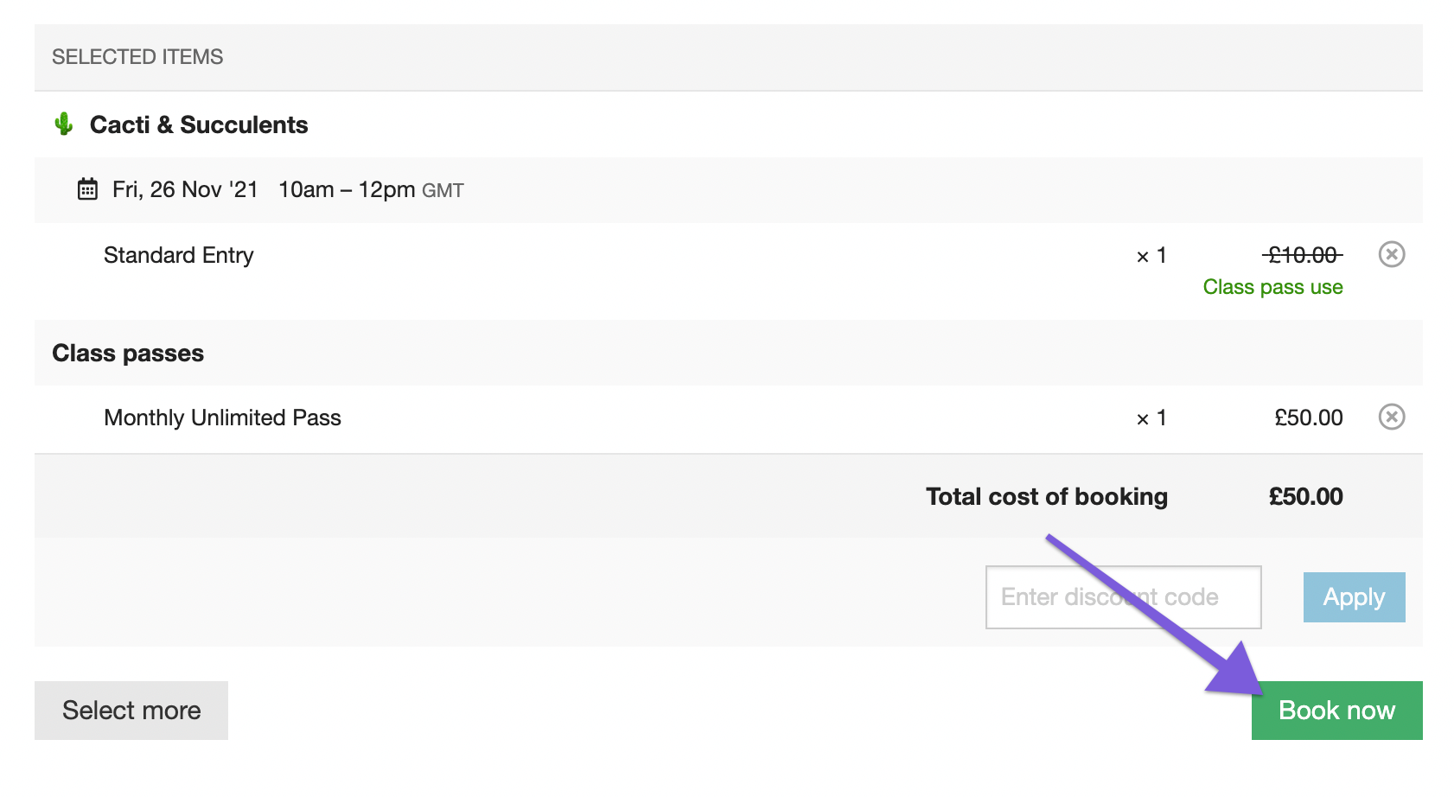

If you don't select an event, you will see the below error message:

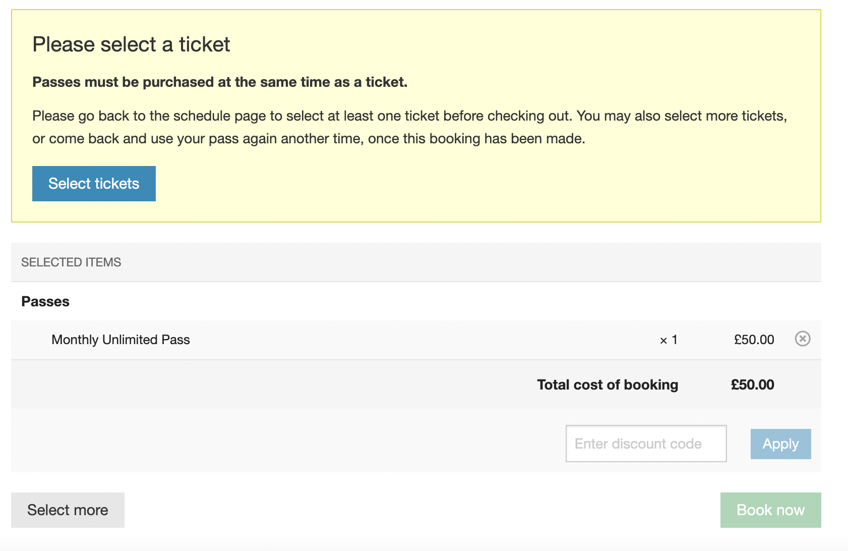

You can see the included tickets under the ticket options.

**How they will appear *after* you have added a Pass to your basket:**

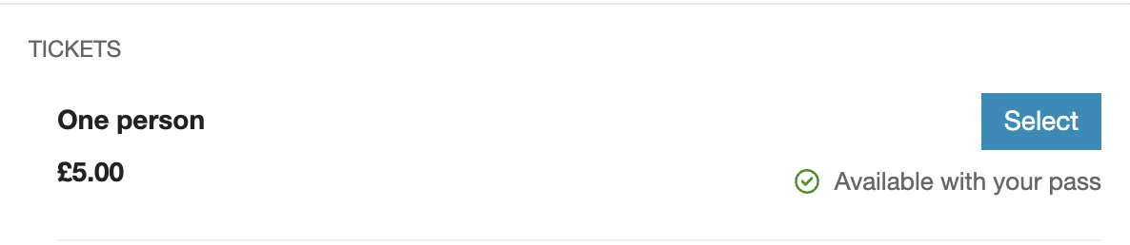

**How they will appear *before* you have added Pass to your basket:**

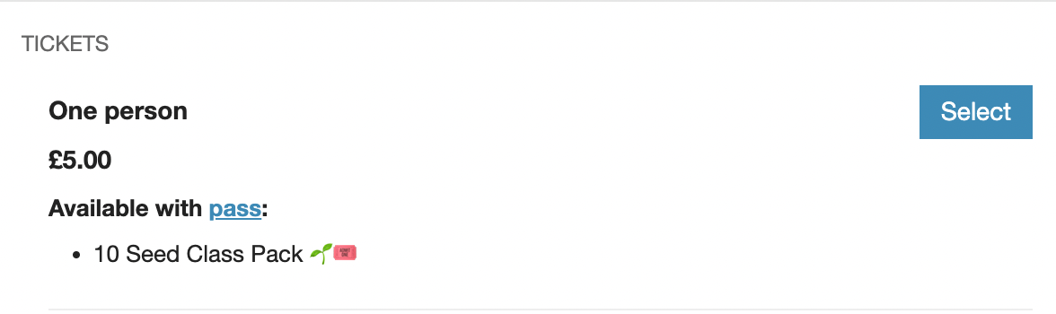

💡 *If preferred, you can select more than one valid class in the initial Pass booking.*

Redeeming your Pass

The Pass is linked to your email address, meaning that you won't have to pay every time you book a valid ticket with your Pass.

**💡 Please ensure you always log in and use the same email address during checkout when redeeming your Pass.**

The checkout process is the usual method. On the **Event Organisers** schedule page, valid tickets list which Passes can be redeemed against them.

If your Pass is valid, please select the ticket:

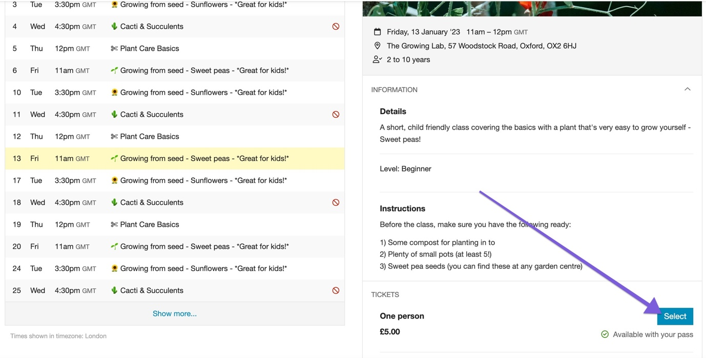

You can either select additional tickets or continue to your basket by selecting **View selections**:

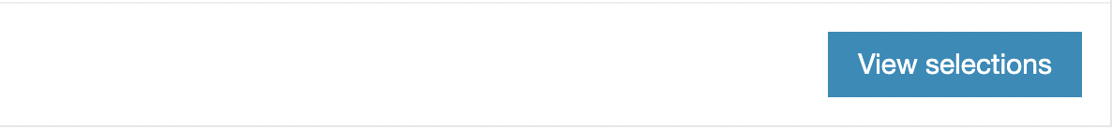

The checkout process is the usual method as described [here](https://intercom.help/bookwhen/en/articles/6465958-tickets), except you will see '*Pass use*' under the price, and you won't be charged for the valid ticket:

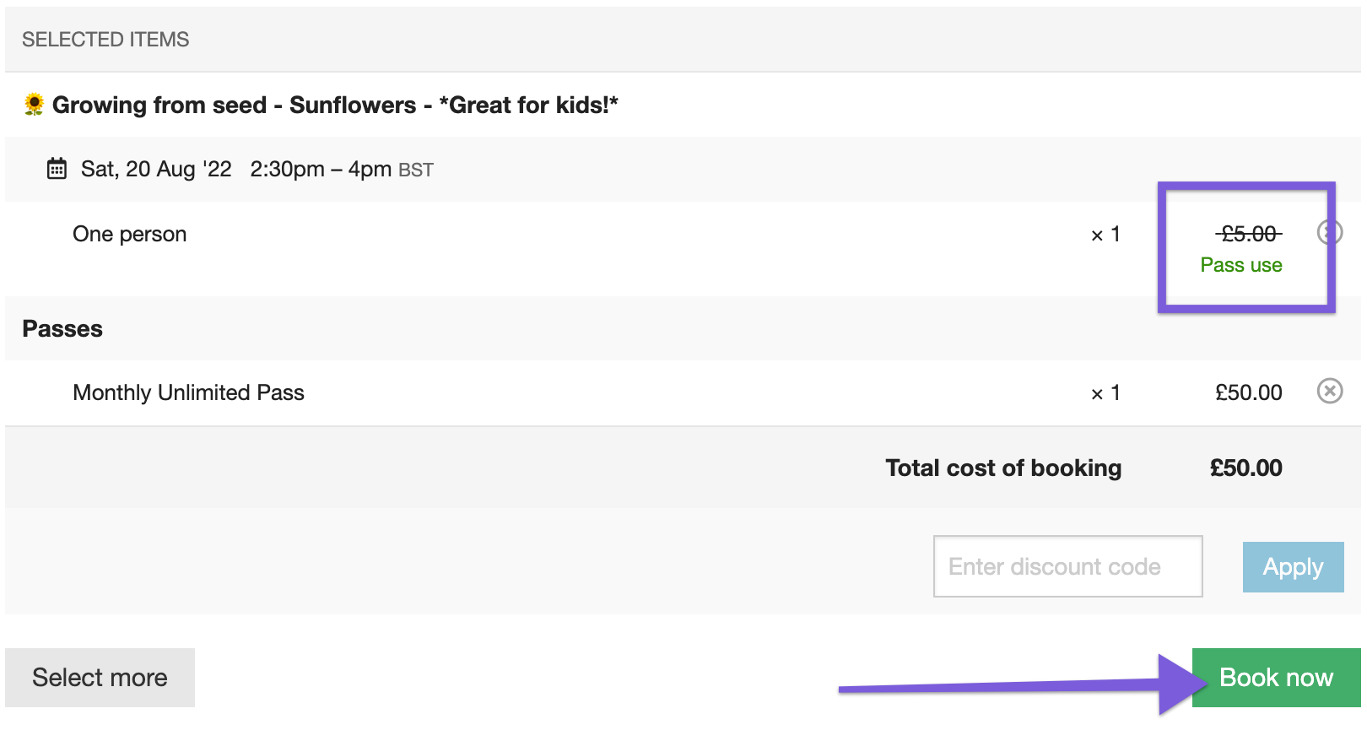

After selecting **Book now**, the system will ask you for your email address:

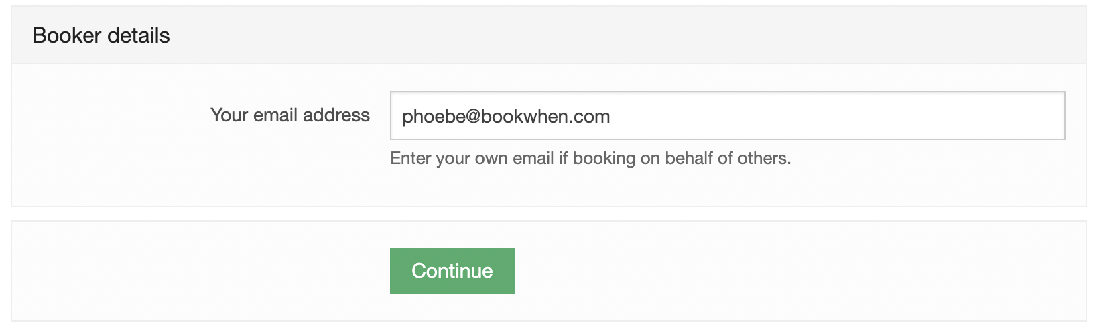

💡 *Please ensure you use the same email address you entered when purchasing the Pass. You will also be asked for your password if you have previously created an account.*

Next, you will be prompted to input the Attendee details plus any further information required by the **Event Organiser**:

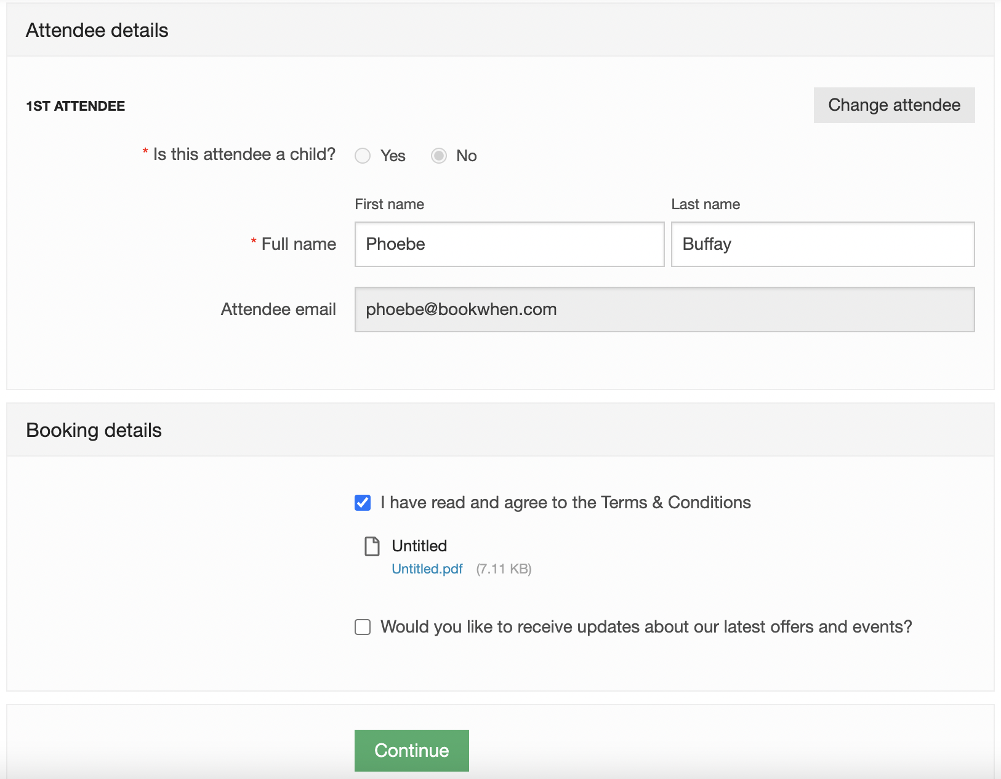

💡 *Please note: It might not be possible to book yourself and another onto a class using the same Pass, depending on the pass settings. In this case, each pass holder must complete their booking.*

You complete the booking by selecting **Continue**, where you will see a booking confirmation message. As a Pass holder, you should not be asked to pay at this stage unless you choose tickets that are not valid with your Pass.

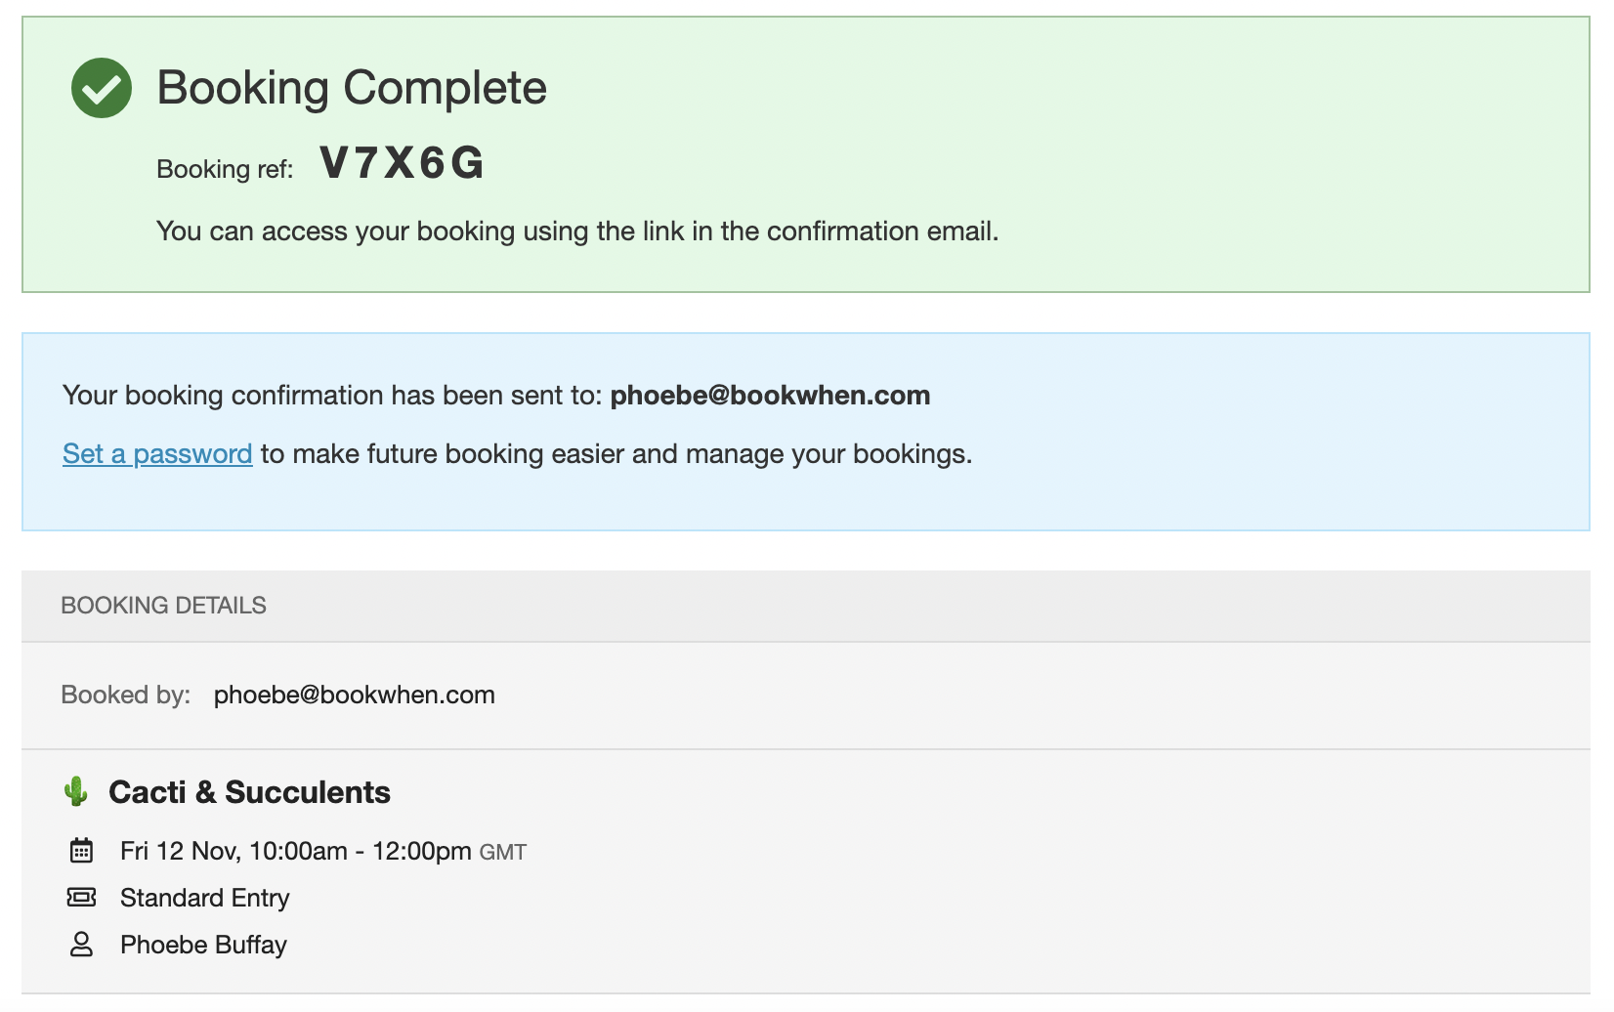

**Restrictions**

* You cannot redeem a pass against a course, group, or free ticket.
* In the case of multiple passes on your account, eligible ticket purchases will be redeemed against the oldest pass, not the one with the most recent expiration date.

Managing a Pass

Once you have completed a booking and [created a password](https://intercom.help/bookwhen/en/articles/6466709-account-password), you can log into your account to view the remaining uses on your Pass and its expiry date.

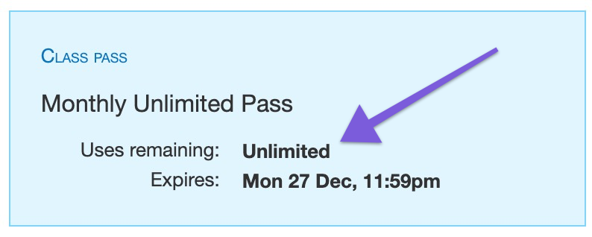

**How to view the remaining uses on a pass**

There are two ways you can do this; either log in to your account from the **Event Organiser's** booking page by selecting **Log in** in the top right-hand corner, then **View bookings**:

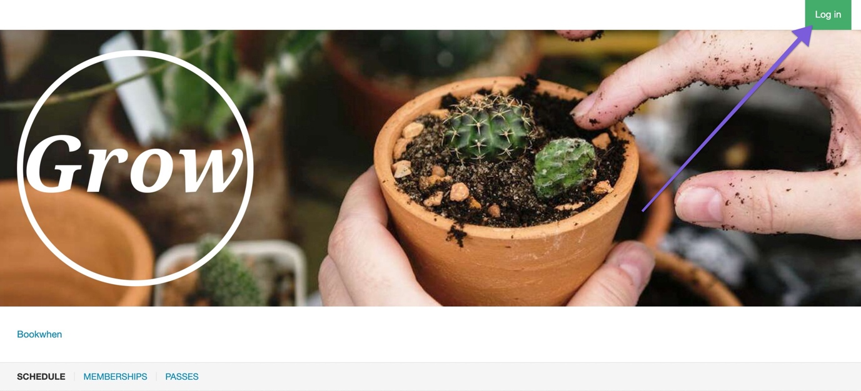

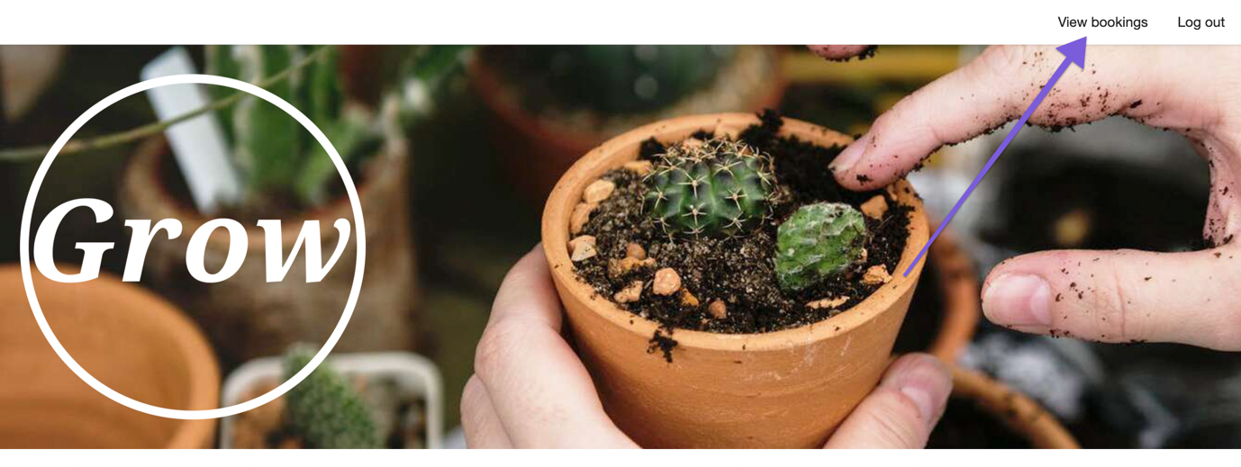

Or view your booking directly from your booking confirmation email and select the **View booking** button:

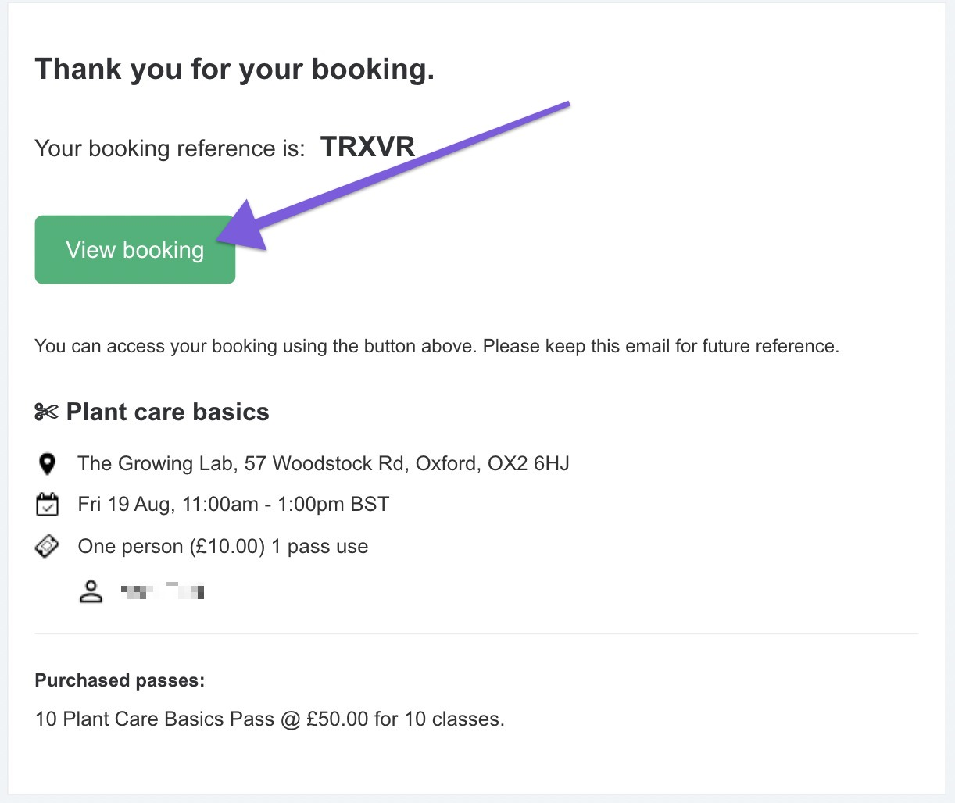

You will then see a page similar to the one below:

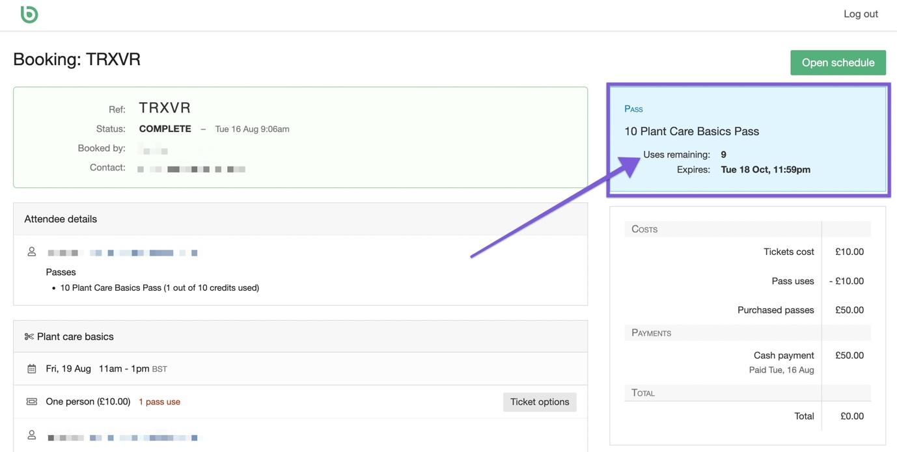

You can view how many uses remain in the top right-hand corner in the blue box.