**VE Day Afternoon Tea**

**The Clarendon Hotel, Blackheath**

**Join us for a nostalgic VE Day celebration Afternoon Tea, served**

**A selection of traditional finger cut sandwiches, union jack scones with nostalgic mini cake selection will be served from 8th – 11th May**

**The Clarendon will be marking the 80th anniversary of this special day with a blaze of Union Jacks flying the whole length of the Clarendon Hotel for the period.**

**‘Period dress is encouraged’**

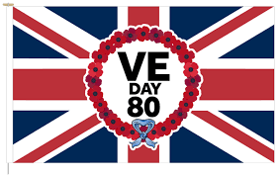

**Menu**

**Selection of Freshly Made Nostalgic Finger Sandwiches**

**Smoked Salmon and Cream Cheese**

**Egg Mayonnaise and Mustard Cress**

**Honey Roast Ham and Mustard**

**Homemade Fruit Scones Served with Cornish Clotted Cream and English Strawberry Days Preserve**

**VE Day Mini Cake Selection**

**Sherry Trifle Pots**

**Victoria Sponge cake**

**School Days Sprinkle Cake**

**V.E. Day Afternoon Tea £26.50**

**Sparkling with a glass of Kentish Chaple Down Wine £33**