

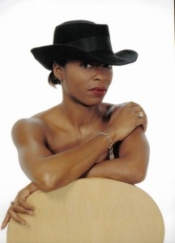
Tina T's Tamla -Motown Night
Friday 16th October - 3 Course Dinner & Tina T’s Show £55
An Evening of Tamla Motown & Soul, with timeless hits,
Soulful classics, an unforgettable night of live entertainment.
Join us for a spectacular evening with Tina T, as seen on BBC One’s All Together Now, and special guest Oli Arlotto on saxophone, as they bring the iconic sounds of Tamla Motown and Soul to life.
Enjoy a delicious three-course dinner before dancing the night away to timeless classics from Marvin Gaye, Diana Ross, Smokey Robinson, Martha Reeves, The Temptations, Stevie Wonder, Tina Turner, The O’Jays and many more.

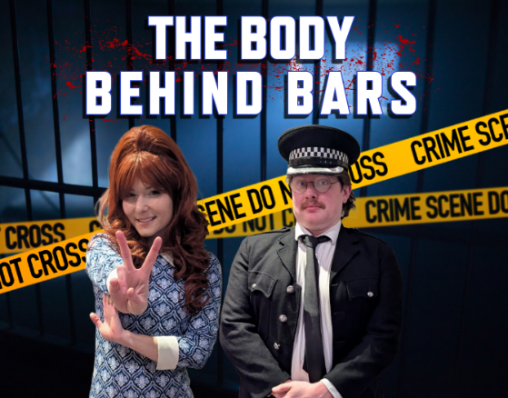
Murder Mystery Dinner Friday 13th Nov
3 Course Dinner & Murder Mystery Show £59
The Body Behind Bars
Step back into London in the swinging 60's, where the nation is undergoing a cultural revolution; but there’s seediness lurking in the shadows. Crime is rife in the Capital and makes criminal-gotten gains ripe for the picking…that is, if you’re brave enough to chance it.

One such chancer, a petty criminal linked to the Krays, is being held at a station awaiting trial; both sides of the law have eyes on him and want their revenge. Surely the safest place for him would be behind a locked cell door? Think again, as morning comes for him, as has his maker, as they are discovered murdered in their cell! Was it murder for money? Or perhaps a motive more personal is lurking beneath it all…
Join the Clarendon Hotel & Moonstone Murders for an evening of Murder Mystery, packed with plot twists, suspicious suspects, and plenty of red herrings along the way! But can you catch the killer?
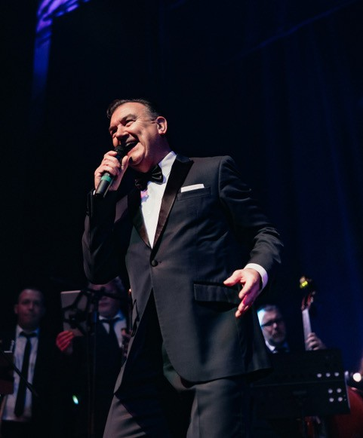
PRIZE FOR THE BEST DRESSED - SO DRESS TO IMPRESS
aiden kent swing evening
Friday 30th October - 3 Course Dinner & Show £55
Returning to the Clarendon, Aiden Kent who will take you back to the classic era of the Las Vegas Casino’s and those unforgettable vocals all shaken together like a heady cocktail with some breezy Bossa Nova’s to stir the mix.

Bookings: - www.clarendonhotel.com Tel – 0208 318 4321

Jazz @ the Row Live free Jazz every other Thursday 7.30pm

