Forged in Nature Outdoor Education
Home Education Forest School
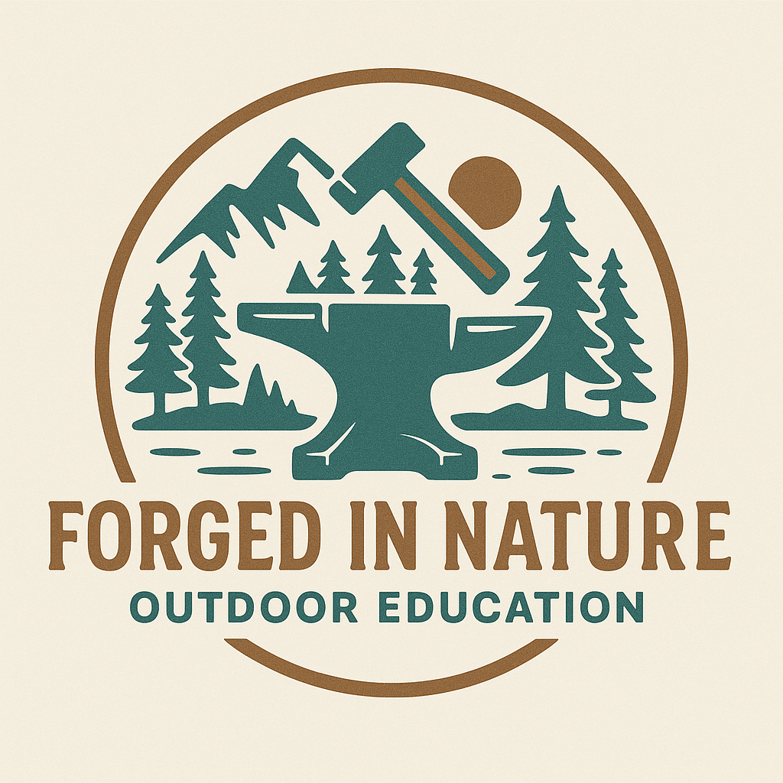

Forest School Child Information Form
Child Name:

My child likes to be called:

Date of Birth:

Age:

Address:

Gender / Identity:

Religion (if any):

Languages Spoken:

Does your child have any fears or phobias?:

Any additional learning needs or disabilities?:

Photo Consent
I give permission for my child to be photographed during Forest School sessions. Images may be used for learning records, safeguarding documentation, and promotional materials for Forged in Nature Outdoor Education.
Yes ☐ No ☐

Medical Information
Any medical conditions?:

Illnesses / Medications taken:

Allergies (e.g. pollen, nuts, materials):

Has your child ever been stung by a wasp or bee?:

If yes, please describe the reaction:

Will your child need medication while at Forest School? Yes ☐ No ☐

If yes, please specify medication, dosage, and storage instructions:

Do you consent to the Forest School Leader administering lotions such as insect sting/repellent, burns gel, sun cream, or Savlon? Yes ☐ No ☐

Do you consent for Forest School staff to remove ticks with a tick removal tool if needed? Yes ☐ No ☐

Parent / Guardian Details (Two Required)

Parent / Guardian 1
Name:
Home Phone Number:
Mobile Number:
Email Address:

Parent / Guardian 2
Name:
Home Phone Number:
Mobile Number:
Email Address:

Doctor / GP Information
Doctor / Surgery Name:
Phone Number:

GDPR & Data Protection Consent
Forged in Nature Outdoor Education is committed to protecting your personal data. Information collected on this form is used solely for safeguarding, health and safety, and the effective running of Forest School sessions. Data will be stored securely and will not be shared with third parties unless legally required or for emergency medical care.
I consent to Forged in Nature Outdoor Education storing and processing this information in accordance with GDPR regulations.
Signature of Parent/Guardian: ________________________ Date: __________

